**Ecoblitz Report**

# Spring: March 10 - May 10, August 10 - October 10: Fall

# ANOVA + Tukey Honest Significant Differences

|  |  |  |
| --- | --- | --- |
|  | Spring | Fall |
| Average temperature | P= 0.0299  2023 is different | p= 0.00418  2022 is different |
| Max. temperature | p = 0.0105  2023 is different | p=0.00314  2022 is different |
| Min. temperature | p= 0.238  Not significant | p=0.00311  the difference is only between 2021 -2022 |

At 95% sig. level

|  |  |  |
| --- | --- | --- |
| Mean average temp. | Spring | Fall |
| 21 | 51.10484 | 68.74194 |
| 22 | 51.28226 | 72.91935 |
| 23 | 47.91935 | 68.66935 |

**Spring: 2023 was 4 degree cooler**

**Fall: 2022 was 4 degree warmer**

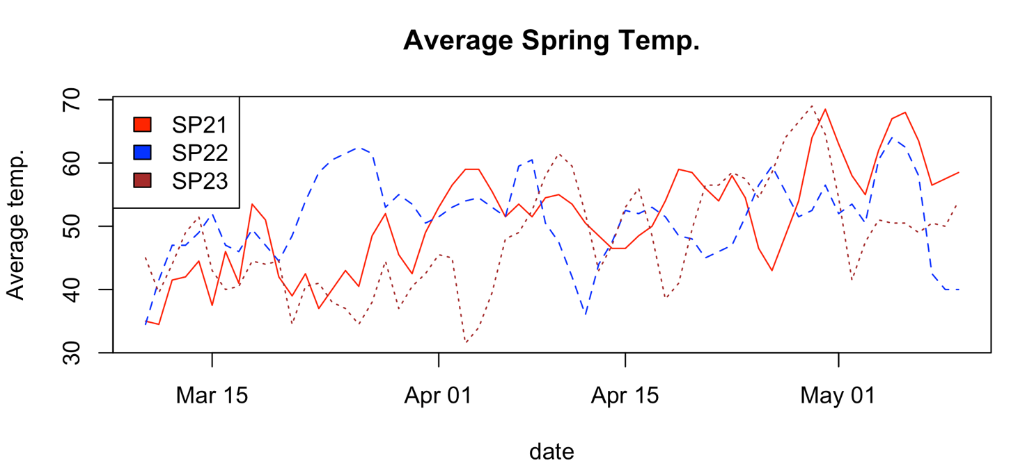

**For 1 week,**

**Spring: May 4 – May 10**

**Fall: Aug 29- Sept 10 in 2021, Around Sept 27 – Oct 3 in 2022,2023**

|  |  |  |
| --- | --- | --- |
|  | Spring | Fall |
| Average temp | P=0.000484  2021 is different | p= 0.000479  2023 is different |
| Max | P=0.00217  2021 is different | p=0.000185  2023 is different |
| Min | p= 0.0807  Not significant. | p=0.177  Not significant |

**Average Spring temp. for a week**

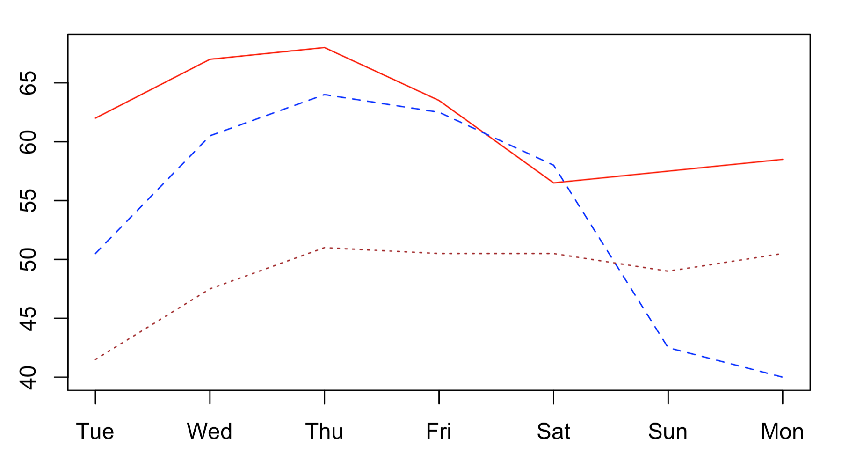

**Max. Spring Temp**

**Flower**

**Spring Frequency Tables**

2021 2022 2023

**Fall**

ANOVA

|  |  |  |
| --- | --- | --- |
|  | Spring | Fall |
| Only Buds | P= 6.99e-05  Everything is different | p = 0.198  Not sig. |
| Early | P= 6.99e-05  2023 is different | p = 0.0995  Not sig. |
| Peak | p = 0.233  Not sig. | p = 0.813  Not sig. |
| Late | p = 0.0117  2021 is different | p = 0.372  Not sig. |
| Only Fruits | p = 0.657  Not sig. | p = 0.245  Not sig. |